PSG COLLEGE OF TECHNOLOGY, COIMBATORE -4
DEPARTMENT OF APPLIED MATHEMATICS AND COMPUTATIONAL SCIENCES
III M.Sc Data Science - 5th SEMESTER
15XD56 - JAVA PROGRAMMING LAB PROBLEM SHEET – 5

To demonstrate packages.
1. Develop a Class named CONVERSION which includes Methods to perform the following tasks stored inside of MyJavaPackage.MyConversion
- To convert inches to centimeters I Inch = 2.54 Cm
- Convert centimeters to inches.
- There are 454 grams in a pound and 1000 grams in a kilogram. Write a method to convert pounds to kilograms and kilograms to pounds
- Conversion from miles to kilometers I Mile = 1.609344 Km.
- Converting minutes to hours, minutes and seconds
- Fahrenheit to Celsius and Celsius to Fahrenheit 1 Celsius = 33.8 Fahrenheit.
Write an interactive Test program to perform the above conversions. Store your code in a package named MyJavaPackage .MyPrograms.

2. Create a package that contains the following classes
I ) a class ‘SentenceGenerate’ that uses random-number generation to create sentences. Use four arrays of strings called article, noun, verb, and preposition.
The arrays of Strings:
  - The article array should contain the articles: "the", "a", "one", "some", "any"
  - The preposition array should contain the prepositions: "to", "from", "over", "under", "on"
  - The noun array and the verb array should contain words entered by the user. So start the java application program(driver) by asking the user to enter 5 nouns, and then ask them to enter 5 verbs. Store these in the appropriate arrays
Create a sentence by selecting a word at random from each array in the following order: article, noun, verb, preposition, article, noun
As each word is picked, concatenate it to the previous words in the sentence. The words should be separated by spaces. When the final sentence is output, it should start with a capital letter and end with a period. The application should generate random 20 sentences and output them to the console
II ) a class ‘WordGenerate’ Perform the following:
repeatEnd("Hello", 3) → "llollollo"
repeatEnd("Hello", 2) → "lolo"
repeatEnd("Hello", 1) → "o"

III) Get number of words and number of characters in a string Object.
Develop appropriate methods to implement the above operations. Write a Java application to test your packages.
Sample ouput: (I)
-----------------------
Enter 5 nouns : truck car dog man boy
Enter 5 past tense verbs : ran jumped killed attacked cried

Some truck cried from the truck.
One boy jumped under the car.
Any car jumped from some man.

- Create a packege MyJavapackage.MyAnimals in which you will create a hierarchy of animals that is rooted in an abstract class Animal. Several of the animal classes will implement an interface called Pet. Experiment with variations of these animals, their methods, and polymorphism
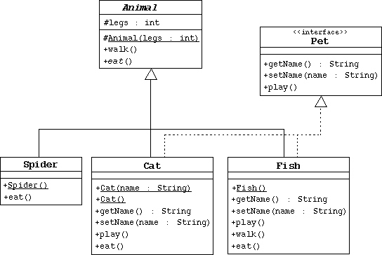

- Create the Animal class, which is the abstract superclass of all animals.
  - Declare a protected integer attribute called legs, which records the number of legs for this animal.
  - Define a protected constructor that initializes the legs attribute.
  - Declare an abstract method eat.
  - Declare a concrete method walk that prints out something about how the animals walks (include the number of legs).
- Create the Spider class.
  - The Spider class extends the Animal class.
  - Define a default constructor that calls the superclass constructor to specify that all spiders have eight legs.
  - Implement the eat method.
- Create the Pet interface specified by the diagram.
- Create the Cat class that extends Animal and implements Pet.
  - This class must include a String attribute to store the name of the pet.
  - Define a constructor that takes one String parameter that specifies the cat's name. This constructor must also call the superclass constructor to specify that all cats have four legs.
  - Define another constructor that takes no parameters. Have this constructor call the previous constructor (using the this keyword) and pass an empty string as the argument.
  - Implement the Pet interface methods.
  - Implement the eat method.
- Create the Fish class. Override the Animal methods to specify that fish can't walk and don't have legs.
- Create an TestAnimals program. Have the main method create and manipulate instances of the classes you created above. Start with:
Fish d = new Fish();
Cat c = new Cat("Fluffy");
Animal a = new Fish();
Animal e = new Spider();
Pet p = new Cat();
Experiment by: a) calling the methods in each object, b) casting objects, c) using polymorphism, and d) using super to call super class

